
Lesson 8: Under Pressure
GameMaker
VIDEO GAME CREATION
This week: give the enemies you dodge last week actual stakes. An enemy reaching the bottom now costs a life - lose all 3, and "Game Over" appears.
Open your own [YourName]Game project from Lesson 7 - don't start a new one.
Tip: the core exercise needs no new assets - this reuses last week's escape-cleanup code and just gives it a real consequence. For Level 3 sound, use the provided sfx_lifelost.wav and sfx_gameover.wav from the Lesson 8 Assets folder.

Setup
- Open your [YourName]Game project from Lesson 7.

Level 1 - Minimal (MVP)
Every enemy that reaches the bottom unshot now costs the player one life, tracked starting at 3. The moment lives reach zero, "Game Over" appears on screen.
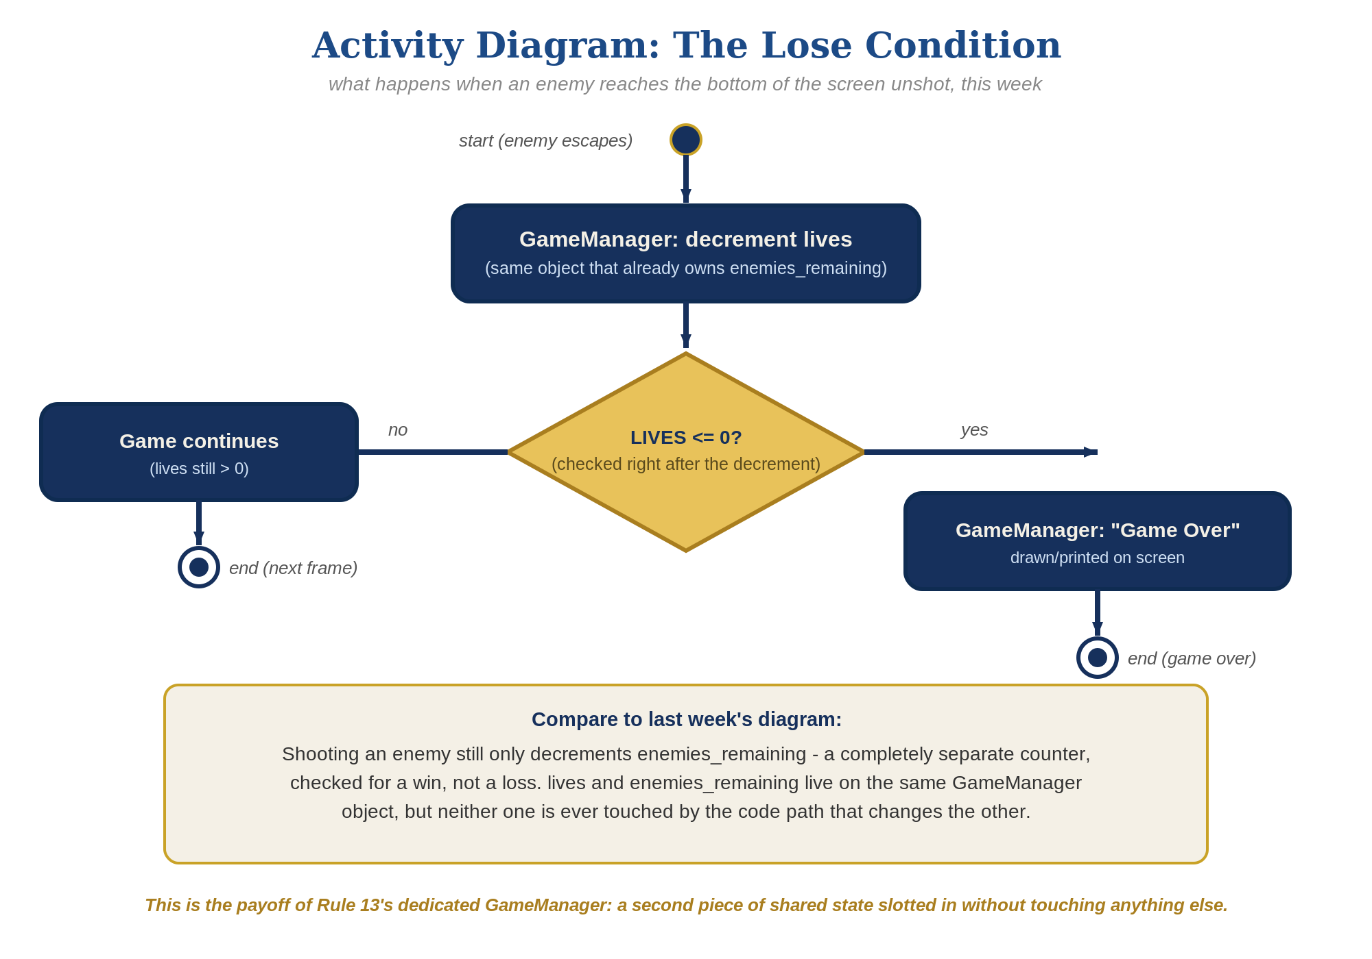
The lose-condition logic behind this week's exercise - the same shape in every engine, whatever the exact code or blocks look like.
- On obj_gamemanager's Create event, add __dnd_lives = 3; and has_lost = false; alongside your existing enemies_remaining and has_won. (__dnd_lives is the instance variable GameMaker's own drag-and-drop Lives blocks use - the "dnd" stands for drag-and-drop. Use it instead of the old built-in lives, which is deprecated, so code and blocks stay interchangeable.)
- On obj_enemy's Step event, find the escape-cleanup code you built last week. Right before instance_destroy(), add the lives decrement and zero-check, targeting obj_gamemanager (code below).
- On obj_gamemanager's existing Draw GUI event, add a second if block that draws "Game Over" when has_lost is true, right after the existing has_won block (full code below, new lines highlighted).
- Press F5 (Run) and let all 3 lives run out by letting enemies escape unshot - "Game Over" should appear the instant the third one escapes.
Highlighted lines are new this week; everything else is code you already have.
// obj_gamemanager's Create event:
enemies_remaining = 5;
has_won = false;
__dnd_lives = 3;
has_lost = false;
// obj_enemy's Step event:
y += enemy_speed;
if (y > room_height) {
obj_gamemanager.__dnd_lives -= 1;
if (obj_gamemanager.__dnd_lives <= 0) {
obj_gamemanager.has_lost = true;
}
instance_destroy();
}
// obj_gamemanager's Draw GUI event:
if (has_won) {
draw_text(400, 50, "You Win!");
}
if (has_lost) {
draw_text(400, 90, "Game Over");
}

Alternate Path: GML Visual (no typing)
The same lives-tracking pattern works with drag-and-drop blocks instead of typed code, targeting obj_gamemanager the same way the code path does. GameMaker's Lives blocks are purpose-built: they keep an instance variable named __dnd_lives (not a global), so each block needs its Target set to obj_gamemanager. The code path uses that same variable, so the two paths are interchangeable.
- On obj_gamemanager's Create event, add a "Set Lives" block (Instance Variables category) with Value 3 and Relative unchecked, then a Set Variable block setting has_lost to false (has_lost is a custom variable with no dedicated block).
- On obj_enemy's Step event, inside the existing If Variable block checking y against room_height, add a "Set Lives" block: click the Target drop-down arrow (upper right of the block) and choose obj_gamemanager, set Value to -1 and check Relative. Then add an "If Lives" block, also with Target set to obj_gamemanager, Expression set to less than or equal to, and Value 0. Drop a "Set Variable" block to the side of it (inside the If) setting has_lost to true on obj_gamemanager.
- On obj_gamemanager's existing Draw GUI event, add a second "If Variable" block checking has_lost, with a "Draw Text" block inside it - set its X to 400, Y to 90, and Text to "Game Over", matching the code path's exact values.
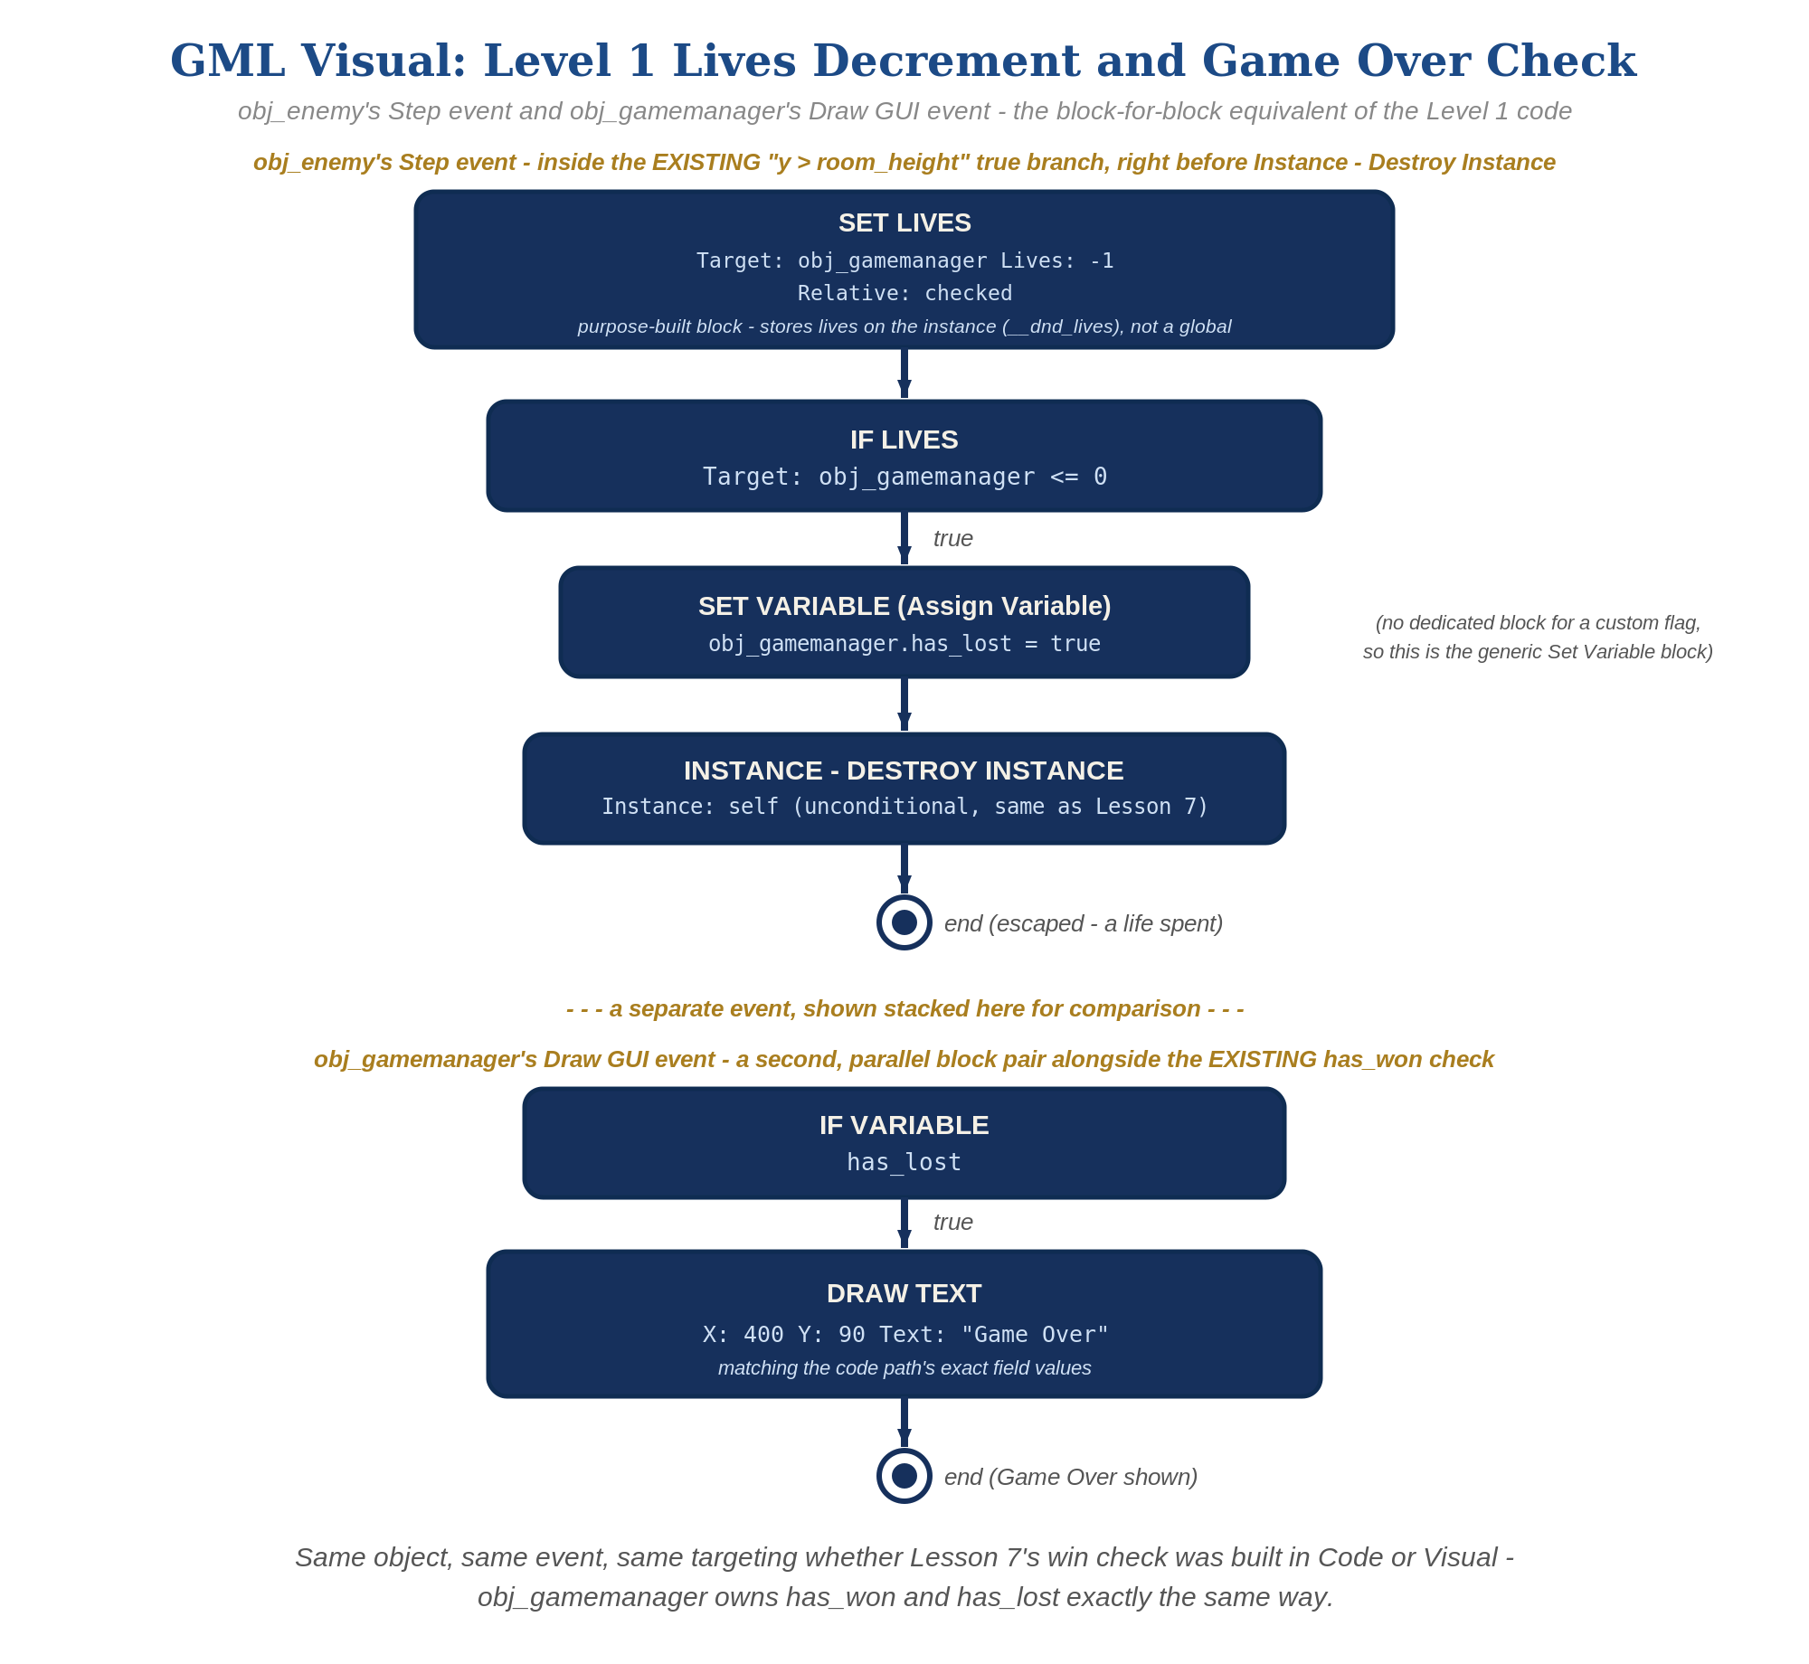
obj_enemy's Step event and obj_gamemanager's Draw GUI event, in GML Visual - the block-for-block equivalent of the Level 1 code.

Level 2 - Complete (Alpha/Beta)
Shooting an enemy never costs a life, and letting one escape never counts as a kill - the two counters stay completely independent.
- Shoot an enemy and confirm lives does NOT change - only obj_bullet's Collision event, and enemies_remaining, should be involved.
- Let an enemy escape and confirm enemies_remaining does NOT change - only obj_enemy's Step event, and lives, should be involved.
- Confirm "Game Over" appears exactly once, exactly when lives reaches zero.

Level 3 - Refined (Ready to Publish) - pick any that interest you
- Visual: add a second draw_text() call in obj_gamemanager's Draw GUI event showing the current __dnd_lives value every frame (e.g. draw_text(20, 20, "Lives: " + string(__dnd_lives))) - a nice touch, though the full scoreboard-style UI is coming properly in Lesson 9. Visual path: a "Draw Instance Lives" block (Drawing category) on obj_gamemanager's Draw GUI event, choosing spr_player as the sprite, draws one small ship per life - or a "Draw Value" block with Caption "Lives: " and Value __dnd_lives.
- Sound: import the provided sfx_lifelost.wav and sfx_gameover.wav as new sound resources (keep the default names, sfx_lifelost and sfx_gameover), then call audio_play_sound() right where __dnd_lives decreases in obj_enemy's Step event - sfx_lifelost normally, sfx_gameover instead when lives reaches zero and has_lost becomes true.
- Structure: obj_enemy's Step event now handles movement, escape cleanup, AND reaching out to obj_gamemanager for lives - all genuinely the same concern ("this enemy left the screen unshot"), while obj_bullet's Collision event stays the only place enemies_remaining changes, and obj_gamemanager stays the only place any shared game state lives at all. Two clearly separated jobs, one dedicated manager, same as last week.

If Something's Wrong
- Lives decreases when you shoot an enemy: confirm the lives decrement is only in obj_enemy's Step event, not accidentally copied into obj_bullet's Collision event too.
- "Game Over" never appears: confirm __dnd_lives actually starts at 3 in obj_gamemanager's Create event (a Set Lives block with Value 3, Relative unchecked, in the Visual path), and that the Step event's threshold (y > room_height) is actually being reached.
- Visual path: Set Lives and If Lives both need their Target (drop-down arrow, upper right of the block) set to obj_gamemanager - left on the default, they change or check lives on the enemy itself, and Game Over never appears.
- Error referencing obj_gamemanager: confirm there's actually exactly one obj_gamemanager instance in the room - the same requirement enemies_remaining already relies on.
- "Game Over" and "You Win!" overlap on screen: adjust the Y coordinate in the has_lost draw_text() call (e.g. 90 instead of 50) so the two messages don't draw on top of each other.

Want More?
Student Resource List > GameMaker section, or gamemaker.io/en/tutorials

